Date: March 10, 2023

**Sir Jay-Ar Lalata**

Sir Jay-Ar Lalata, TX22

Dear Prof. Jay-ar Lalata:

May I respectfully request to take the Special Exam for Summative Assessment 3 which I missed last **Febuary 27** due to Sickness

Attached is the evidence that shows why I was not able to take the Summative Assessment.

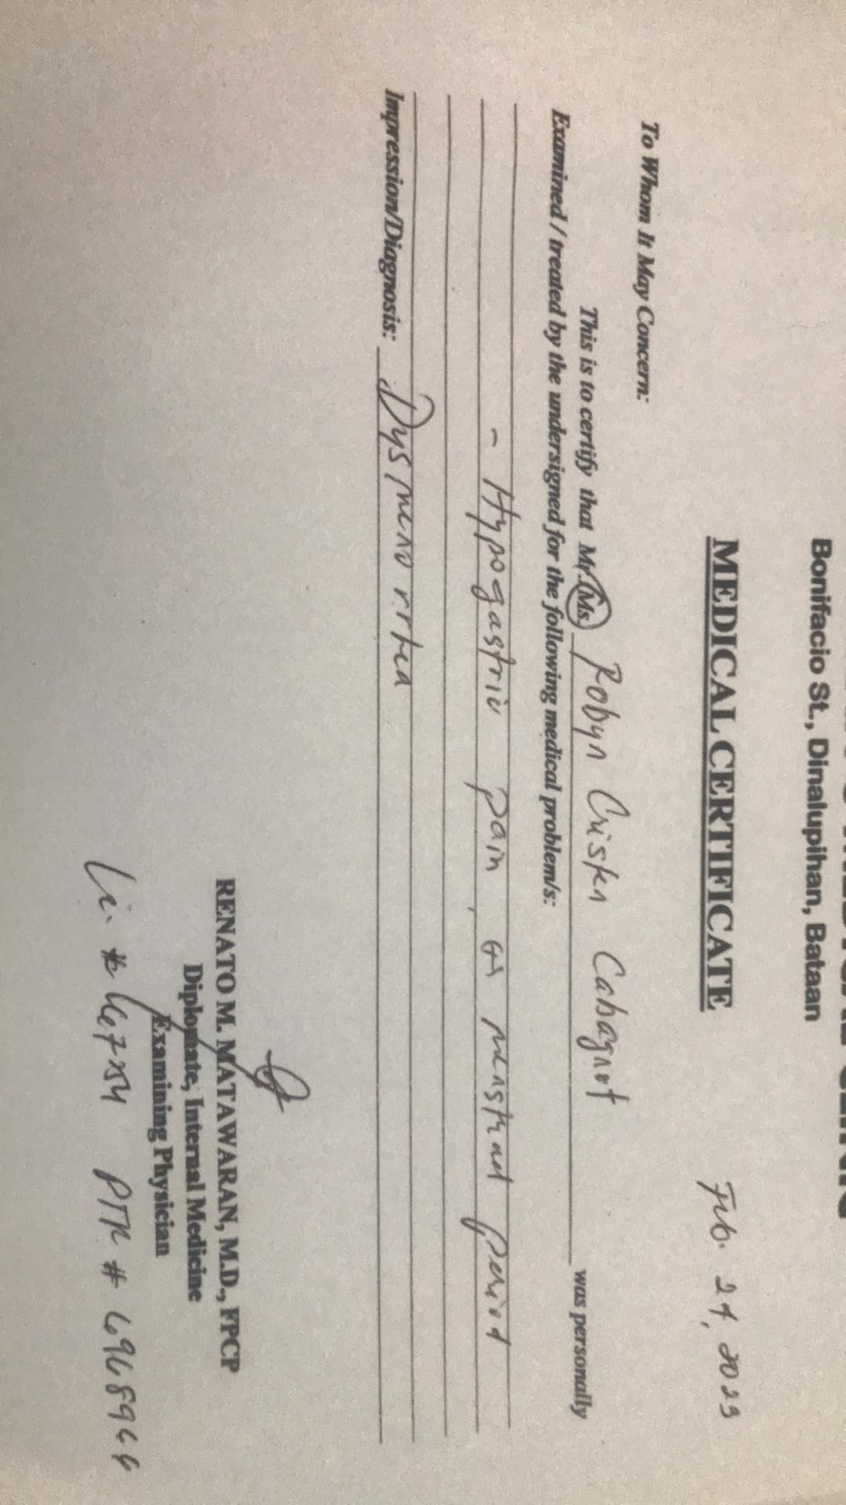

Thank you for your kind consideration and I am looking forward for your approval.

Respectfully yours,

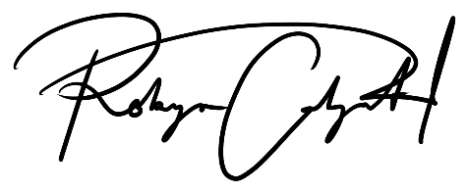

**Robyn Cristen A. Cabagnot**

202010810